Team - Cult of Cactaur
Brian Smith
Chris Haire
Roger Norris
Jason Shelton

XenoHammer: Progress Report

Development has been progressing very well since our last milestone. We have successfully completed our “Desired Target” originally slated for completion on Nov 10th. There were 4 major areas that were worked on to complete the target.

Desirable Target –(Nov 10th)
2 levels, | Complete (Oct. 22nd)
collection of resources, | Complete (Oct. 3rd)
scoring system (kills and pilot ranking), | Complete (Oct. 3rd)
in game variant energy settings, | Complete (Oct. 3rd)
real enemy AI (with ability to turn ships dynamically) | Complete (Oct. 3rd)
2 types of enemies, | Complete (Oct. 3rd)
all 3 player weapons have 5 different firing modes | Complete (Oct. 3rd)
finalized sound effects, | Complete (Oct. 22nd)
customization GUI, | Complete (Oct. 22nd)
player/ship save | Complete (Oct. 22nd)

In attempting to add two distinct levels, we encountered some implementation issues modifying the engine to handle the “state” of multiple levels. This was an unexpected setback, but was worked through with just a little extra work required. Also, when working with multiple levels, we realized that it is difficult to “gracefully” handle the death of the player.

The sound effects have basically been finalized. Some small tweaking might occur, but we have chosen the sounds we feel should be in the game. Tweaking of the sounds will require normalization of all the volumes to help give the best balance of background music and game sounds. A friend of the group was nice enough to create a dance music track specifically for our game. As a result, we have been able to script our levels to directly follow the intensity of the background music. As the music builds to a frenzied pace, more and more enemies pour on screen bombarding the player. We feel that this in a great addition to the game as it helps instill a sense of “urgency” in the player.

The customization GUI is at the core of ship modification. The GUI allows the user to distribute their resources to the different ship systems and save the settings. (See screenshot 1) All of the player information is displayed to the user. Each system and its energy breakdown is shown in the upper left region of the screen. The “Ship Update” window in the lower right region of the screen updates to give you real-time feedback on the changes you’re making. When “All systems are selected” is clicked, all of the update information will be displayed, otherwise it only displays for the selected system. The shields bar, is a constantly recharging bar that shows you how fast your shields will recharge based on the current energy setting. The small fighter icon on the bottom of the box flies left and right based on the current engine power settings. When a specific system is selected, the NoseBlaster for example, the GUI switches to allow customization. (See screenshot 2) A “left” and “right” arrow appears in the power system allowing the player to transfer power to either power cell. Also the status window becomes active and displays additional information about the power system. In this window, you can trade in collected resources into power units for a specific system. At a later time, you may also be able to purchase upgrades for weapons, like homing missiles. Note that in this screenshot only the NoseBlaster is firing.

Also completed is the save/load feature. We haven’t implemented the player loading yet, due to lack of an effective way to present the feature in the current GUI. This will be updated at the next demo. However, whenever the game is exited all of the player information is saved to a file, so that the player can continue their journey on next start-up.

Additionally, there were some changes made in the engine to allow for our composite capital ships. (See screenshot 3) The composite ship is composed of many individually destroyable components, a common feature found in games of this type. We wanted to put in this functionality, but we were not sure if it was feasible given the time constraints. Fortunately, with a little extra work it came out great and adds a lot to the battle with the capital ship. Note that the left turret and left wing have been destroyed in the battle.

The hard work of the team has really shown up to this point. There have been no issues that prevented implementation of a feature that we had wanted to build. We attribute this to our careful planning and hard work. We found that “tuning” the game to be playable, challenging and fun at the same time was pretty hard. Also we have some “issues” with ClanLib. ClanLib can be unstable and the true type font implementation causes a huge hit on performance. We decided to switch to a “manual” font implementation and that was buggy. We did finally get it working, but not without much gnashing of teeth. Overall, we are very pleased with the state of our game and look forward to continuing towards completion.

Screenshot 1
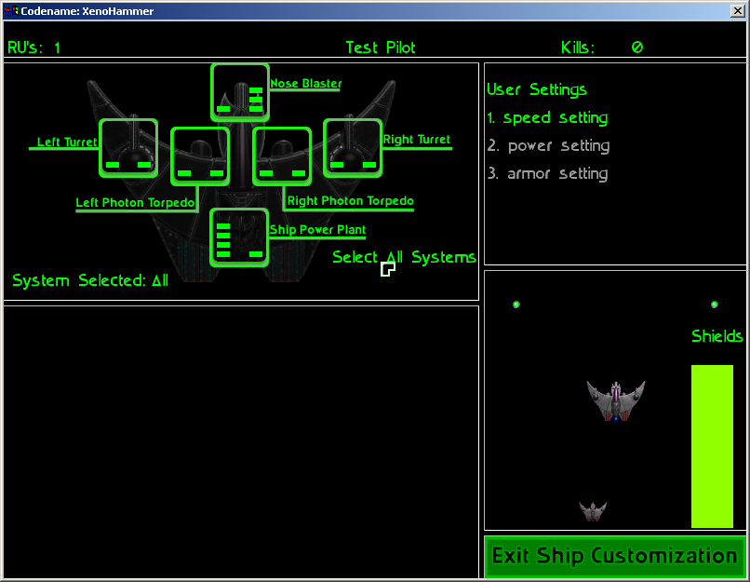

Screenshot 2
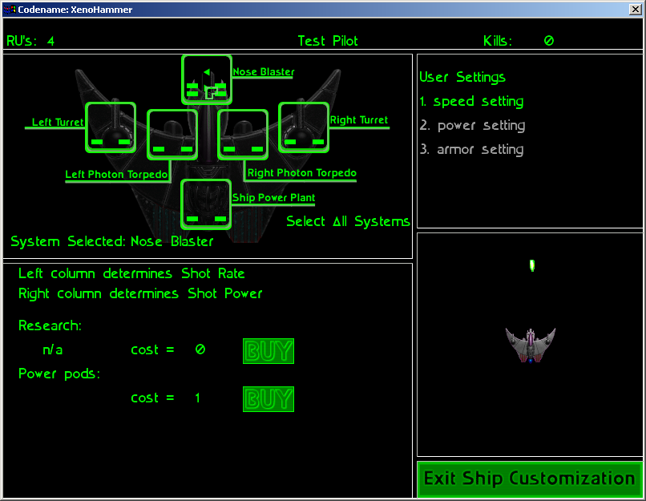

Screenshot 3
